Accessing the Johnson University Library Resources as a Dual-Enrolled Student
- Open a web browser and go to https://my.johnsonu.edu
- On the left-hand side, click on the Quick Link titled “Library”
  - 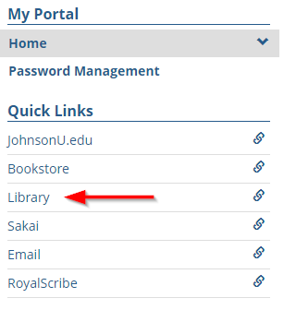
- Once the page loads, find and select the Library Tool that you need.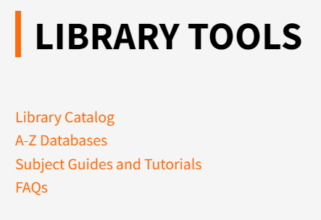
- To find and select the collection or resource you need, open “A-Z Databases”. The page will look like this.
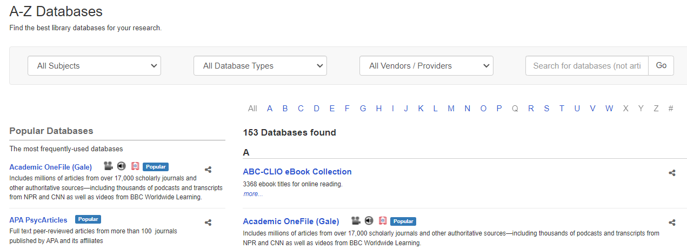
- Once you have selected a collection or resource, you will be greeted with a series of login screens, pictured below. You may see language referencing an email address. For dual-enrolled students, please simply enter the username provided to you.
  - 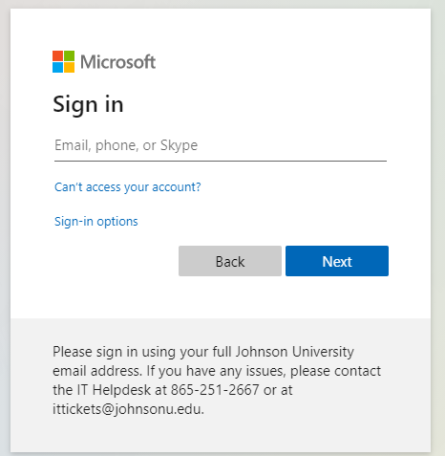
  - 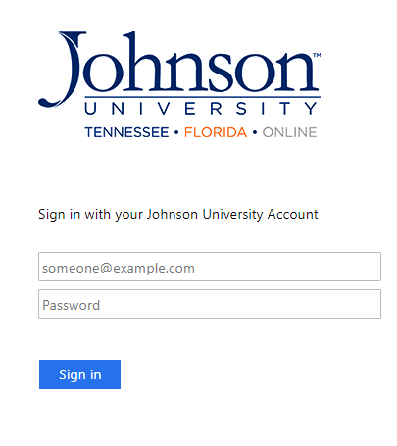
- Sign in with your Johnson University username and password. Your Johnson University Admissions Counselor or your school will give you this information.

